Shelby Bicycle Days
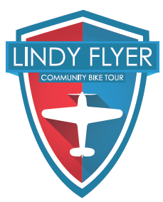
Lindy Flyer Community Bike Tour
11.7 Mile Tour – Green Loop - BEGINNER 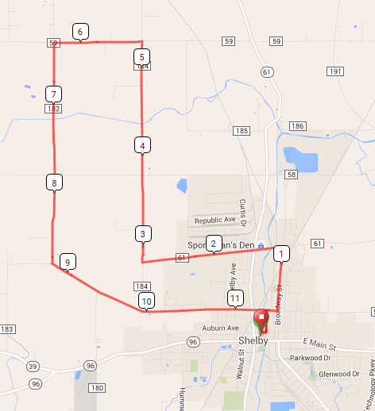
Mile Direction
0.0 R onto W Whitney Ave
0.1 L onto Mohican St
0.5 R onto E Smiley Ave
0.5 L onto Broadway St
1.2 L onto E State St
2.8 R onto Kuhn Rd
5.3 L onto Hazel Brush Rd
6.3 L onto Champion Rd
8.8 L onto W Smiley Rd
11.4 R onto Mohican St
11.6 R onto E Whitney Ave
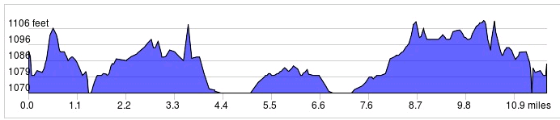
Started In: Shelby, OH
Ends in: Shelby, OH
Distance: 11.7 mi
Elevation: +171/-178 ft
Follow Green Markings: -->>
LF
Sign in and out for each loop
No SAG Vehicles

